Develop A Python Script To Publish And Subscribe To IBM IoT Platform

|  |  |
| --- | --- |
| Date | 18 November 2022 |
| Team ID | PNT2022TMID06181 |
| Project Name | Project – Smart Farmer- IOT Enabled Smart Farming Application |

!pip install ibmiotf

import time

import sys

import ibmiotf.application

import ibmiotf.device

import random

#Provide your IBM Waston Device Credentials

organization="b76hg0"

deviceType="APVD1"

deviceId="Testing"

authMethod="token"

authToken="12345678901"

# Initialize GPIO

def myCommandCallback(cmd):

    print("message received from IBM Iot platform: %s" %cmd.data['command'])

    status=cmd.data['command']

    if status=="motoron":

        print ("motor is on")

    elif status == "motoroff":

        print ("motor is off")

    else :

        print ("please send proper command")

try:

    deviceOptions = {"org": organization, "type": deviceType, "id": deviceId,"auth-method": authMethod, "auth-token": authToken}

    deviceCli = ibmiotf.device.Client(deviceOptions)

#..............................................

except Exception as e:

    print("Caught exception connecting device: %s" % str(e))

    sys.exit()

# Connect and send a datapoint "hello" with value "world" into the cloud as an event of type "greeting" 10 times deviceCli.connect()

#Get Sensor Data from DHT11

deviceCli.connect()

while True:

    temp=random.randint(0,100)

    Humid=random.randint(0,100)

    Mois=random.randint(0,110)

    data = { 'temp' : temp, 'Humid': Humid , 'Mois': Mois}

    #print data def myOnPublishCallback():

    def myOnPublishCallback():

        print("Published Temperature = %s C" % temp, "Humidity = %s %%"%Humid, "Moisture =%s deg c" % Mois, "to IBM Watson")

    success = deviceCli.publishEvent("IoTSensor", "json", data, qos=0, on_publish=myOnPublishCallback)

    if not success:

        print("Not connected to IoTF")

    time.sleep(10)

    # Disconnect the device and application from the cloud deviceCli.disconnect()

    deviceCli.commandCallback = myCommandCallback

OUTPUT:

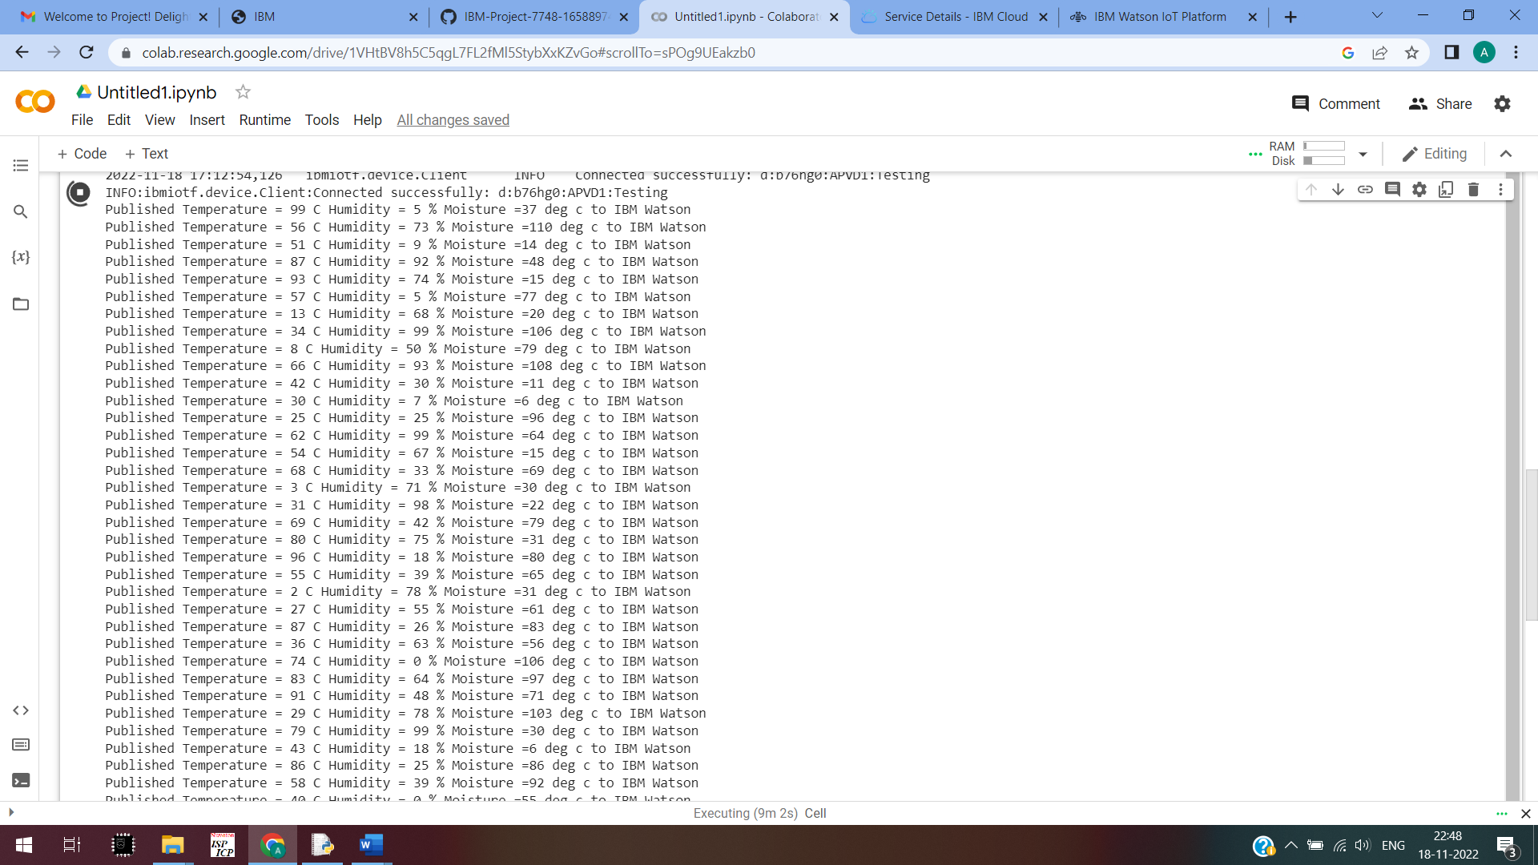

IBM WATSON PLATFORM:

